Materials: pyramid, prism, ruler, water
Part One
1. Using the centimeter side of your ruler, measure the lengths of the sides of the base, and the height of the prism. Record below:
Base Length: _________ Base Width: __________ Prism Height: ___________

2. What is the VOLUME of the prism? ___________

3. Using the centimeter side of your ruler, measure the lengths of the sides of the base, and the height of the pyramid. Record below:
Base length: ___________ Base Width: __________ Pyramid Height: __________

4. Volume is the measure of the _____________ ______________ a figure.

5. How do you think the volume of the pyramid compares to the prism? Does the pyramid have a greater or lesser volume? How much greater or lesser?
Hypothesis: I think the volume of the prism is ___________________________ the volume of the pyramid.

Part Two Raise your hand, and I will check over Part One, and get you set up for Part Two.
6. Test your hypothesis! Using the water I gave you, determine what the relationship is between the two figures. Talk to one another about how you may do this, and explain your process in one or two sentences below.

Part Three Conclusion
7. What did you find?

8. Complete the sentence: The volume of the pyramid is ______________ the volume of the prism.

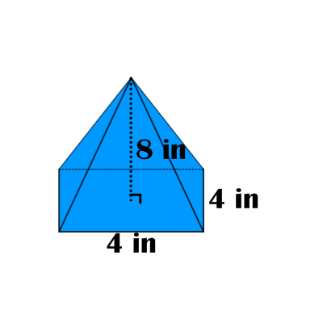
Formula for Finding Volume of a Square Pyramid:

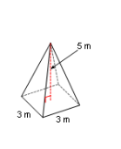
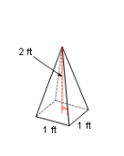
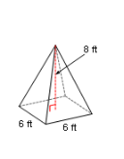
Example Problems:
1. 2. 3.

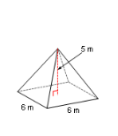
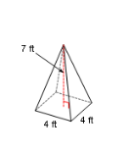
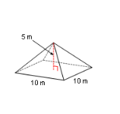
4. 5. 6.

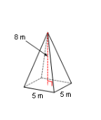
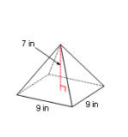
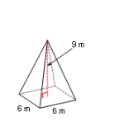

7. 8. 9.

