_______________________________________________________________________________________
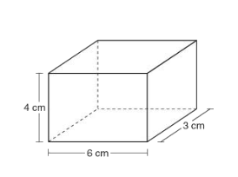
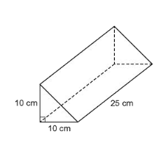
To find the volume of any right prism, multiply the _________ of the ___________ by the ___________ of the prism. *Units are always cubed!!

name of the figure:______________ name of the figure:______________
shape of the base: ______________ shape of the base: ______________
area of the base: ______________ area of the base: ______________
height of prism: ______________ height of prism: ______________

VOLUME: ______________ VOLUME: ______________
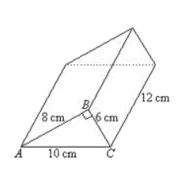
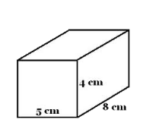

More Examples:

name of the figure:______________ name of the figure:______________
shape of the base: ______________ shape of the base: ______________
area of the base: ______________ area of the base: ______________
height of prism: ______________ height of prism: ______________

VOLUME: ______________ VOLUME: ______________
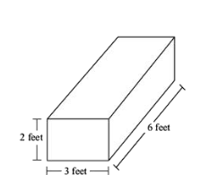
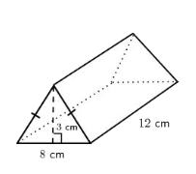

name of the figure:______________ name of the figure:______________
shape of the base: ______________ shape of the base: ______________
area of the base: ______________ area of the base: ______________
height of prism: ______________ height of prism: ______________

VOLUME: ______________ VOLUME: ______________

Table Challenge!
1. | 2.
3. | 4.
5. | 6.
7. | 8.

