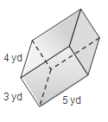
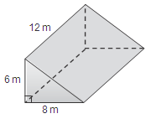
Show the work that leads up to each given volume.
1. 2.

Name of the Figure: __________________ Name of the Figure: __________________
Shape of the Base: __________________ Shape of the Base: __________________
Area of the Base: __________________ Area of the Base: __________________
Height: __________________ Height: __________________
Volume: 288 m³ Volume: 60 yd³

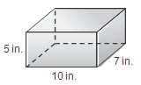
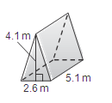
3. 4.

Name of the Figure: __________________ Name of the Figure: __________________
Shape of the Base: __________________ Shape of the Base: __________________
Area of the Base: __________________ Area of the Base: __________________
Height: __________________ Height: __________________
Volume: 27.2 m³ Volume: 350 in³

Draw a picture for each given scenario, and then solve the problem!
5. The United States Post Office has two different priority mail flat rate boxes. Which box has the greater volume? Justify your answer. Box 1: 6$\frac{1}{2}$ in. × 8$\frac{1}{2}$ in. × 11 in. Box 2: 3$\frac{3}{8}$ in. × 11$\frac{7}{8}$ in. × 13$\frac{5}{8}$ in.

6. The ramp leading up to my classroom forms a triangular prism with the ground. The triangular face has a base and height 15 ft by 3 ft, respectively, and the height of the prism is 4 ft. How much space is between my ramp and the ground?

