Making Predictions Homework

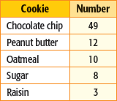The table shows the results of a random survey at Scobey Middle School about students’ favorite cookies. Based on the results from the survey, what percent of students at Scobey Middle like…

1. chocolate chip 2. peanut butter

3. oatmeal 4. sugar

- raisin

- There are 424 students at Scobey Middle School. About how many can be expected to prefer chocolate chip cookies?

- 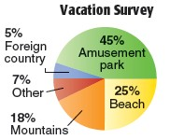The circle graph shows the results of a survey of teens and where they would prefer to spend a family vacation. Predict how many of 4,000 teens would prefer to go to an amusement park.

- In 2000, about 29% of the foreign visitors to the U.S. were from Canada. If a particular hotel had 150,000 foreign guests in one year, how many would you predict were from Canada?

