Guided Practice
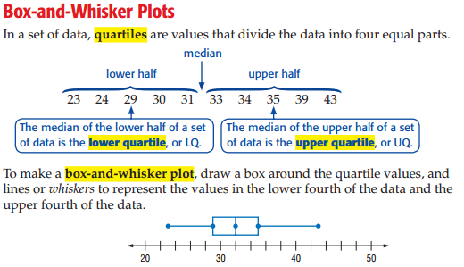

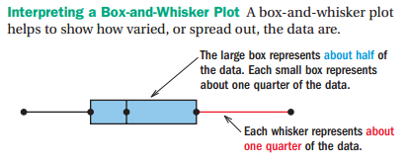

Comparing
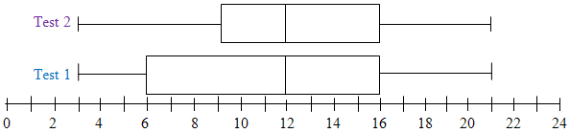

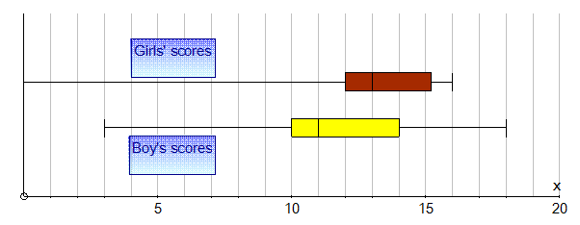

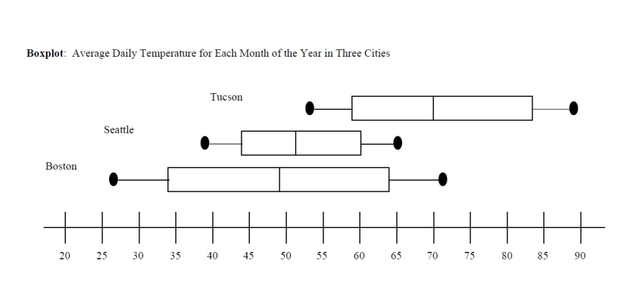
Let’s try it! Box and Whisker Homework
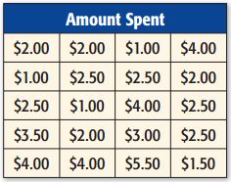
In some schools students have to pay for their lunches. The amount spent in the cafeteria by 20 students is shown. Display the data in a box-and-whisker plot.

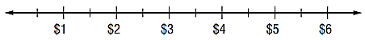

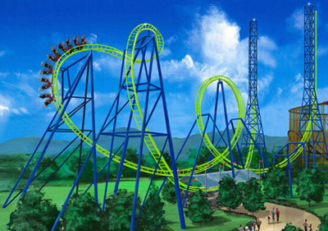
With a Partner!
- Suspended roller coasters are Ms. Chavira’s favorite! They are steep rollercoasters in which the car hangs from the bottom of the track. The heights, in feet, of suspended roller coasters in the United States are given below

35 42 42.5 60 60 70 76 78 81 100

