Prisms:
A prism is a three dimensional figure with ______ congruent, parallel ___________ that are __________.

Prisms get their name by the _______________ of their _______________.

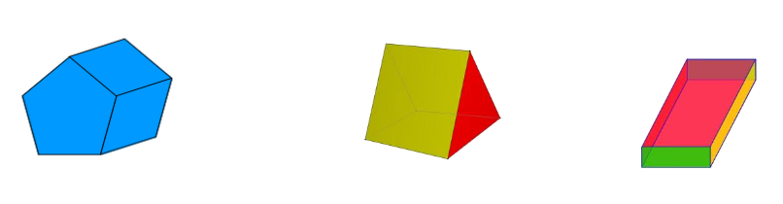
The faces of a right prism are __________________.

Drawing Prisms:

Pyramid:
A pyramid is a three dimensional figure with _________ base that is a ____________; and three or more _______________________ faces that meet at a point.

Pyramids get their name by the _________________of their ____________________.
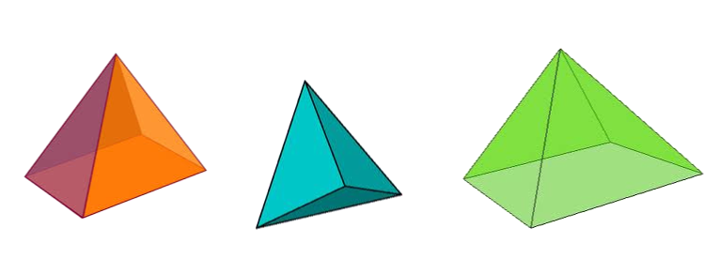

Drawing Pyramids:

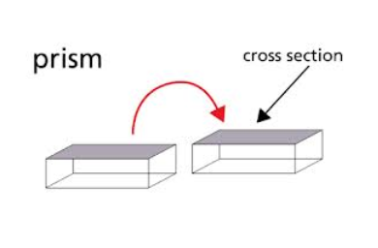
Cross-Section:
A 2-dimensional shape that appears when you _____________ a figure.

Exploring Cross-Sections:
Rectangular Prism:
1. When does a cross-section take the same shape as the base of the prism or a face?

2. Describe how the plane intersects the figure to form a pentagonal cross-section.

Rectangular Pyramid:
1. When is the cross-section a rectangle?

2. When is the cross-section a triangle?

3. Describe how the plane intersects the figure to form a trapezoidal cross-section.

