Scale Factor: The __________ written as a _________ in simplest terms. *Remember, ratios must have the __________ units.

Example 1: Find the scale factor of a model sailboat if the scale is 1 inch = 6 feet
Example 2: What is the scale factor of a model car if the scale is 1 in = 2 feet?
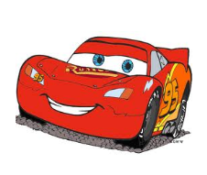
Scale factor can also be used to solve problems. You need to interpret the situation to determine how to use the scale factor. Since a scale factor uses the same units, you may want to think of your unit rate in terms of $\frac{model}{actual}$.

Example 3: A model rocket was built using a scale factor of 1:15. If the height of the actual rocket is 9.9 m, what is the height of the model in millimeters?

Example 4: A backyard playhouse was designed after a real house, using a scale factor of 3:5. If the ceilings in the playhouse are 6 foot tall, how high are the ceilings in the actual house?

Example 5: A dinosaur figurine was built using a scale factor of 1:42. If the actual dinosaur is 12 ¼ feet tall, what is the height of the figurine in inches?

Table Challenge:
1. | 2.
3. | 4.
5. | 6.
7. | 8.

