Center | Shape | Spread
When comparing two populations, we look for and compare the center, shape, and spread of each one – and then draw conclusions, or inferences.

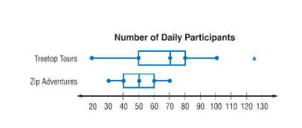
In each problem, look at the two graphs shown, what conclusions can you draw?
1. Conclusion:

Center | Shape | Spread

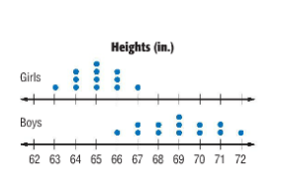

2. Conclusion:
Center | Shape | Spread

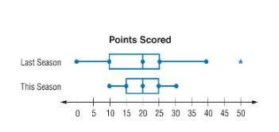
3. The double box plot shows the number of points scored by the football team for two seasons. Compare the centers and variations of the two populations. During which season was the team's performance more consistent?

Center | Shape | Spread

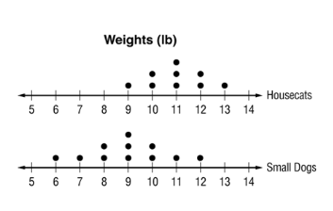
4. Conclusion:

Center | Shape | Spread

