Probability – Simple Events
_______________________ is the chance that some event will occur. A ___________ _____________ is one outcome or a collection of outcomes. An _______________ is a possible results in a probability experiment.

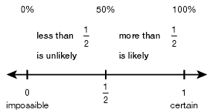
Probability can be written as a ___________________, ____________________ ,or ___________________. It is simply a _______________ that compares the number of favorable outcomes to the number of possible outcomes.

Class Examples:
1. A cube with sides labeled 1 to 6 is rolled. Find P(6) (read the probability of rolling a 6). Express your answer as a fraction, decimal, and percent.

2. A penny is tossed. Find P(heads). Write your answer as a fraction, decimal, and percent.

3. Find the probability of rolling a 2, 3, or 4 on the number cube mentioned in number 1.

4. Find the probability of NOT rolling a 6 in number 1.

5. A bag contains 5 blue, 8 red, and 7 green marbles. A marble is selected at random. Find…
A. P(not red)
B. P(green)
C. P(yellow)
D. P(blue)

