More Angle Relationships – Angles of a Triangle

The angles of a triangle sum to ________________. Therefore, we can write _____________________ to solve for missing values in a triangle.

Examples:

1. 2.



3. 4.



5. 6.

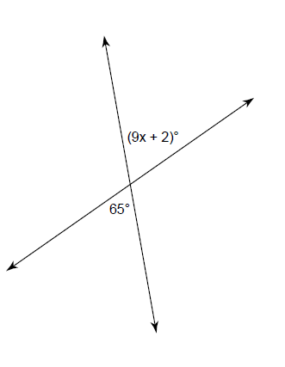

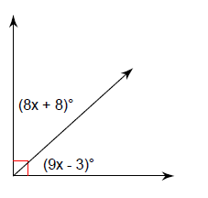Recap:

7. 8. 9.