Complementary, Supplementary, and Vertical Angles

Two angles that sum to 90° are called _____________________________. When put together, these angles form a ________________ ________________.

Sketch:

Two angles that sum to 180° are called _____________________________. When put together, these angles form a ________________ ________________.

Sketch:

Two angles that share a __________________ and are opposite of one another are called __________________ ___________________. These angles are _____________________.

Sketch:

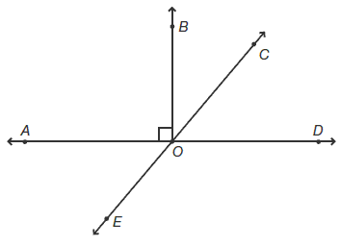

Example 1:

Using the picture at the left, name a pair of:

A. vertical angles:

B. supplementary angles:

C. complementary angles:

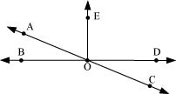

Example 2:

Using the picture at the right, name a pair of:

A. vertical angles:

B. supplementary angles:

C. complementary angles:

Problem Solving with Angles

If we know the relationship between two angles, we can set up an ______________________ to solve for unknown values.

1. 2.

3. 4.

5. 6.

7. 8.