Tables and Equations of Proportional Relationships – Homework
Tell whether the relationship is a proportional relationship. If so, give the constant of proportionality.
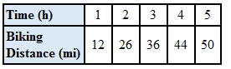
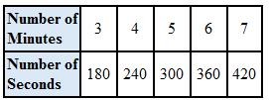
- 2.

- Naomi reads 9 pages in 27 minutes, 12 pages in 36 minutes, 15 pages in 45 minutes, and 50 pages in 150 minutes.

Write an equation for the relationship, and then answer the question. Identify the unit for x and y.
- It takes Li 1 hour to drive 65 miles, 2 hours to drive 130 miles, and 3 hours to drive 195 miles. How many miles can he drive in 5 hours?

- There are 3.9 milligrams of calcium in a ½ ounce of cooked chicken. How many milligrams are in 6 ounces?

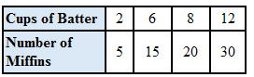
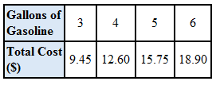
- 7.

